Lab Guide 7

Managing Resources : Resources in Deployments, quota

Q.2 Create a deployment with cpu and memory limits only with 200mb ram and 400m cpu value.
Q.3 Create a deployment with cpu and memory limits and requests also with any value.
Q.4 create a quota in your own namespace that pods=4, svc=2
Q.5 Create one Limit range with any value.

Ans: 2
vim dep.yaml
cat dep.yaml
oc create -f dep.yaml
oc describe deployment mayank
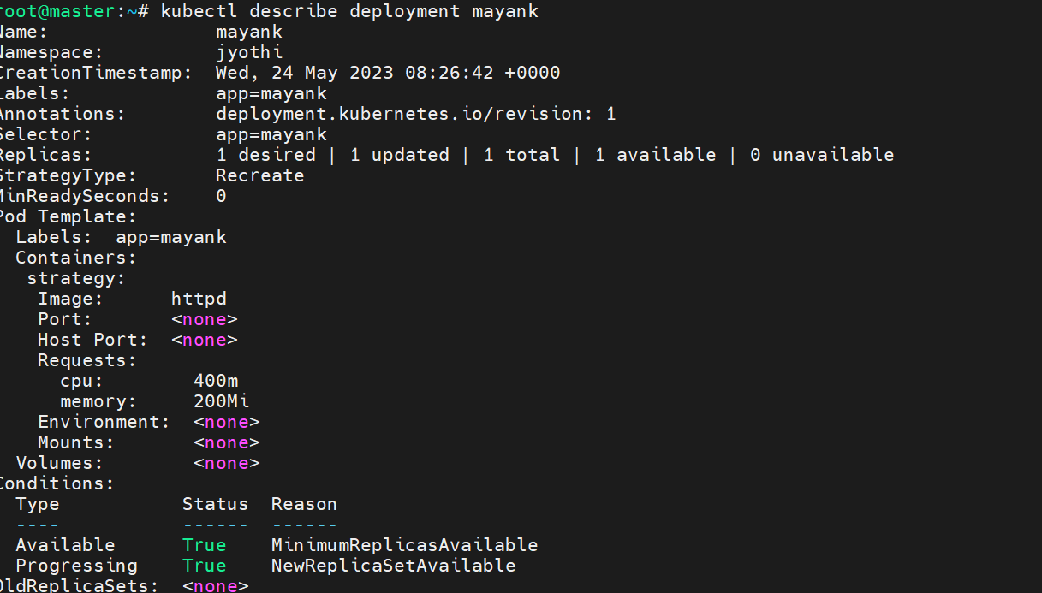

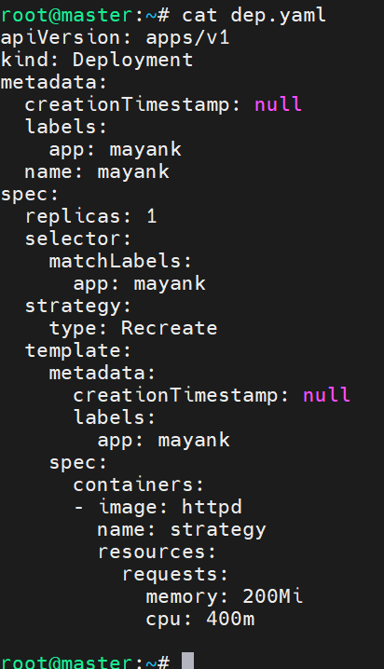

Ans: 3
oc apply -f dep.yaml
oc describe deployment mayank
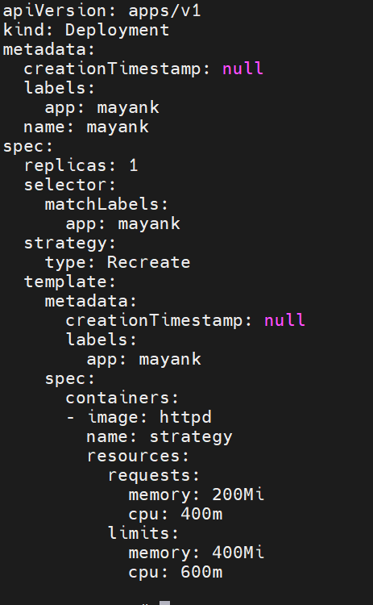
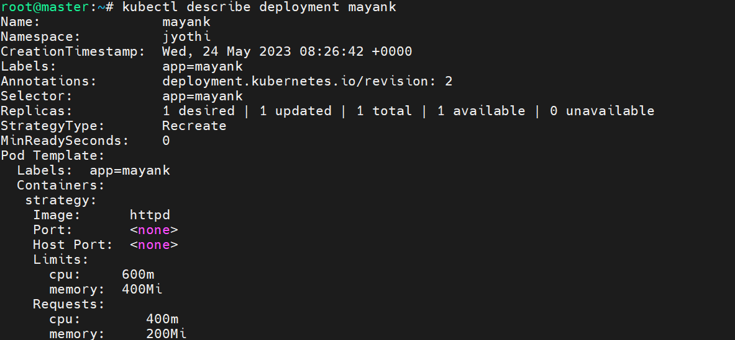

Ans: 4
oc create deployment mayank --image httpd
oc create quota mayankquota --hard=pods=4,services=2
oc scale deployment mayank --replicas 5
oc get pods
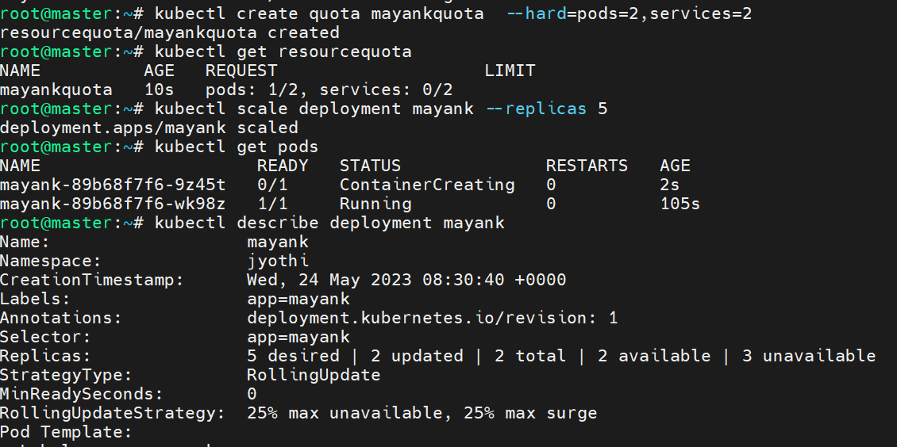
Ans : 5
Cat limitrnage.yml

apiVersion: "v1"
kind: "LimitRange"
metadata:
name: "resource-limits"
spec:
limits:
- type: "Container"
max:
cpu: "2"
memory: "1Gi"
min:
cpu: "100m"
memory: "4Mi"
default:
cpu: "300m"
memory: "200Mi"

oc create -f limitrange.yml
oc get limitrange
oc describe limitrange resource-limits
